Customer Financial Behavior & Risk Analysis
Using Python
Project:
JP Morgan Financial Risk Analysis
Submitted by:
Mohammad Taha
Batch: Data Science Batch
– 15 December

PROJECT OVERVIEW
This project focuses on analyzing customer financial transaction data to identify patterns in account usage, transaction behavior, and financial risks.
The objective is to clean, process, and analyze the dataset using Python and generate insights that help in understanding customer behavior and risk indicators.
Key goals include:
- Understanding transaction trends
- Identifying high-risk accounts
- Segmenting customers based on activity
- Providing data-driven insights for decision making
STEP 1: IMPORT LIBRARIES
Imported essential Python libraries for data manipulation, visualization, and statistical analysis.
- Pandas: Used for handling and analyzing structured data.
- NumPy: Used for numerical operations.
- Matplotlib & Seaborn: Used for data visualization.
STEP 2: LOAD DATASET
Loaded the dataset using Pandas to begin the analysis process.
The dataset was read from a CSV file and stored in a Data Frame for further processing.
Step 3: BASIC EXPLORATION
Performed exploratory checks using shape, info, dtypes and describe to understand dataset dimensions, datatypes and distributions.
Task 1 – Data Cleaning
Performed data cleaning to ensure data accuracy, consistency, and usability for analysis:
- Removed special characters and ensured financial columns contained only numeric values to avoid calculation errors.
- Converted transaction-related columns (TransactionAmount, AccountBalance) into numeric format for proper analysis.
- Handled missing values to prevent incorrect insights.
- Standardized categorical variables such as AccountType and TransactionType for consistency.
- Converted TransactionDate into datetime format to enable time-based analysis.
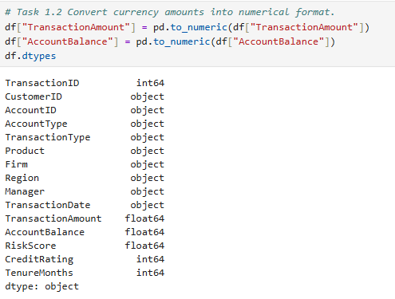
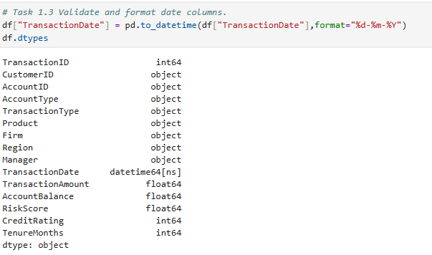

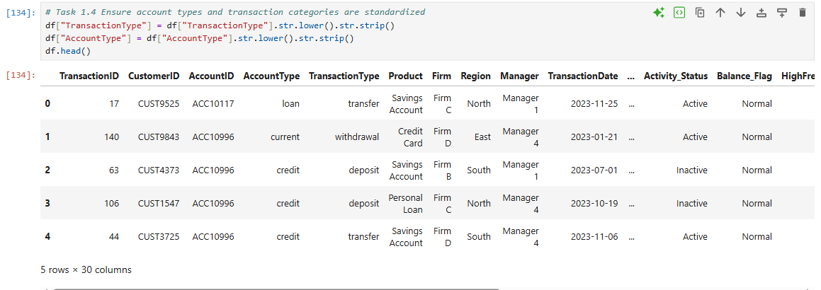

Task 2: Descriptive Transactional Analysis
  - CREDIT vs DEBIT SUMMARY
Analyzed credit and debit transaction trends over time to understand customer financial behavior.
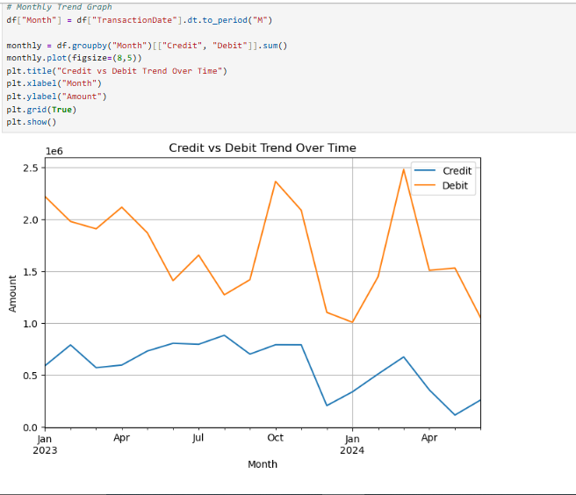
This helps in understanding customer spending and income patterns over time.
Insights: Debit transactions exceed credits in several periods, indicating higher spending behavior among customers.

  - Dormant / Inactive Account Identification
Identified accounts as active or inactive based on the gap between consecutive transactions.
Accounts with a gap of more than 60 days between transactions were classified as inactive.
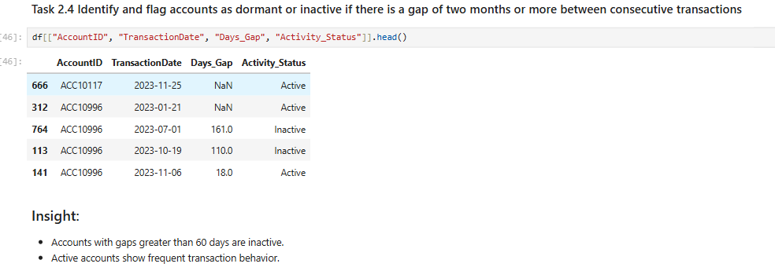
Insights:
- Accounts with transaction gaps greater than 60 days are considered inactive.
- Inactive accounts indicate low customer engagement and potential churn risk.
- Active accounts show regular transaction behavior, reflecting higher customer involvement.
Task 3: Customer Profile Building
3.1 Activity Level Segmentation
Segmented customers based on transaction frequency into High, Medium, and Low activity levels.
- High Activity: More than 50 transactions
- Medium Activity: 20–50 transactions
- Low Activity: Less than 20 transactions
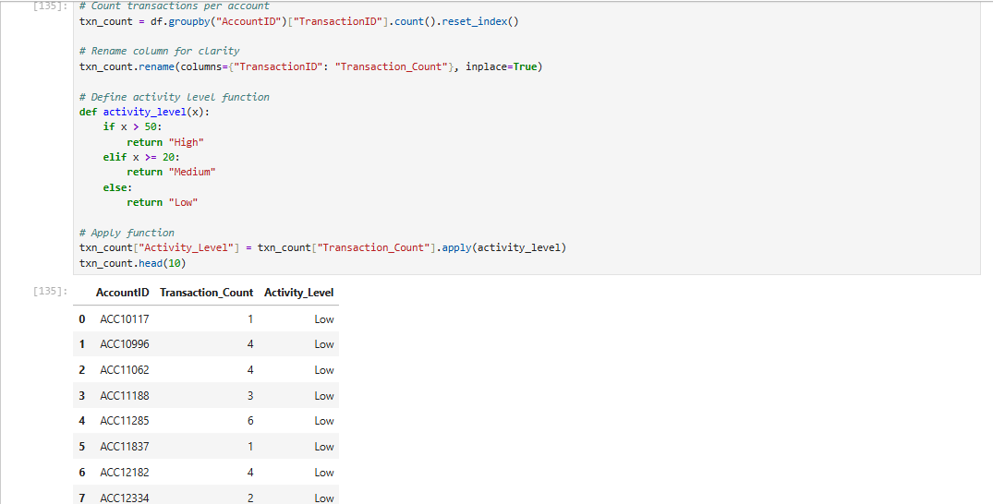

Insights:
- High activity customers frequently interact with their accounts.
- Low activity customers show less engagement and may become inactive.
3.2 Customer Segmentation (Balance & Transaction Volume)
Segmented customers based on their average account balance and total transaction volume.
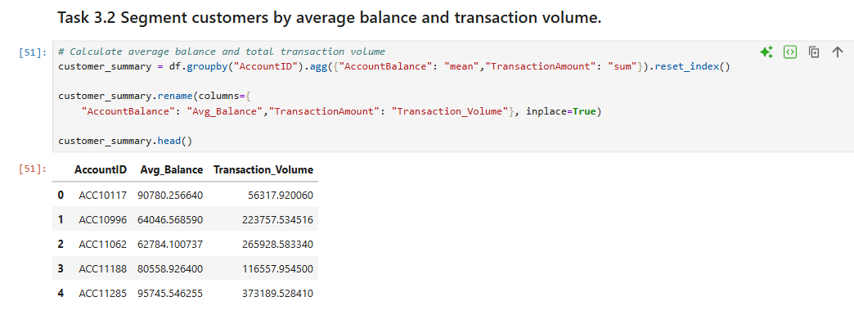

Insights:
- Customers with high balance and high transaction volume are financially strong.
- Customers with low balance may indicate potential financial risk.
3.3 High Net Inflow Accounts
Identified high net inflow accounts based on the top 25% of net transaction values.
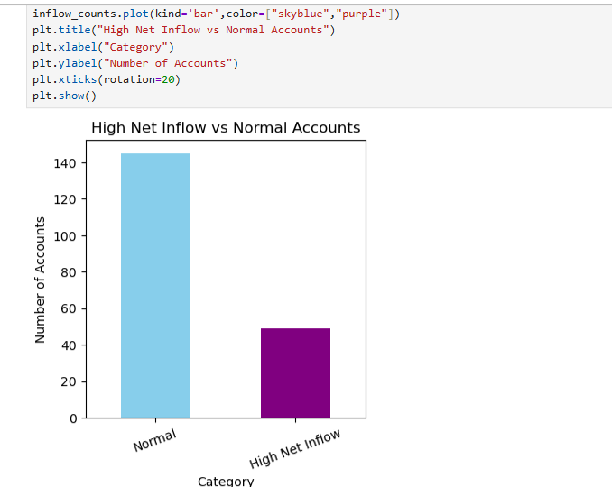
Insights:
- High net inflow customers maintain strong financial activity.
- These customers are valuable for the bank and contribute significantly to overall transactions.

Task 3 Summary-
Customer segmentation highlights different financial behavior patterns across users.
High-value customers contribute significantly to the bank, while low-balance and low-activity customers indicate potential risk areas.
TASK 4. Financial Risk Analysis
4.1 Large / Frequent Withdrawals
Identified accounts with frequent or high-value debit transactions to detect potential financial risk
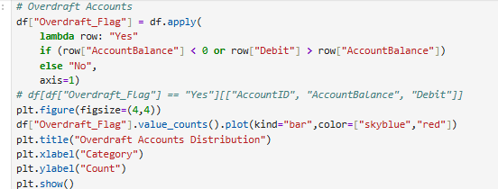
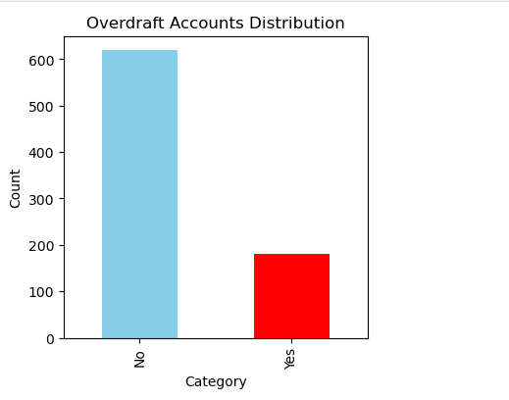
Insights:
- Accounts with frequent large withdrawals indicate higher financial risk.
- Such behavior may reflect overspending or potentially fraudulent activity.
4.2 Balance Volatility
Analyzed balance volatility using statistical measures to identify accounts with unstable financial behavior.
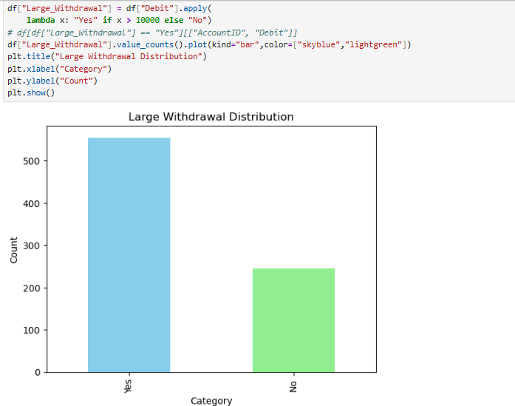
Insights:
- High volatility in account balance indicates inconsistent financial behavior.
- Customers with unstable balances may have higher financial risk.
4.3 Outlier Detection
Detected outliers in transaction amounts to identify unusual or suspicious financial activity.
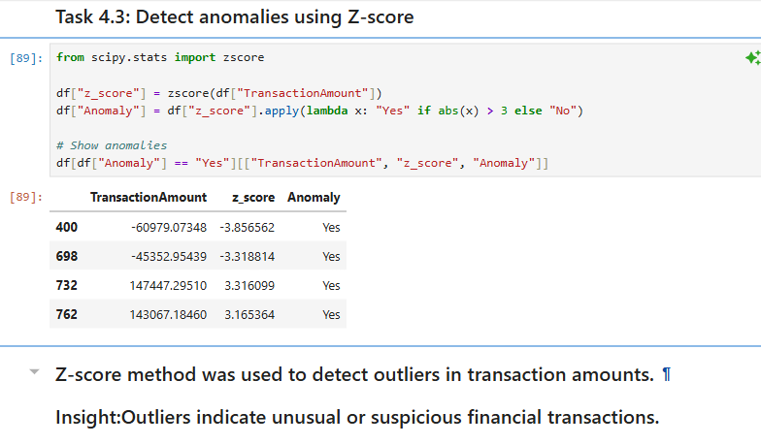
Insights:
- Outliers represent unusually large transactions
- These transactions may indicate potential fraud or high-risk financial behavior.
4.4 Irregular / Suspicious Activity
Analyzed transaction patterns to identify irregular or inconsistent behavior across account.
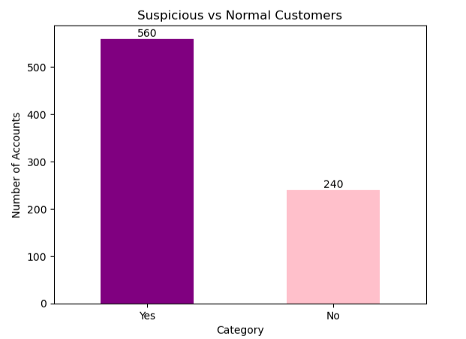

Insights:
- Irregular transaction patterns indicate unpredictable financial behavior.
- Such accounts require monitoring to reduce potential financial risk.
Task 4 Summary:
Financial risk analysis highlights accounts with unstable balances, unusual transactions, and irregular activity patterns.
These insights help in identifying high-risk customers and improving monitoring systems.
TASK 5 - Data Visualization and Insights
5.1 Transaction Type Distribution
Visualized the distribution of different transaction types to understand customer transaction behavior.
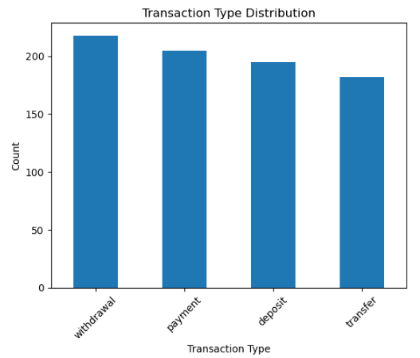
Insights:
- Most transactions are concentrated in categories such as withdrawals and payments.
- This indicates that customers primarily use their accounts for spending activities.
5.2 Credit vs Debit Comparison
Compared total credit and debit amounts to analyze overall financial flow.
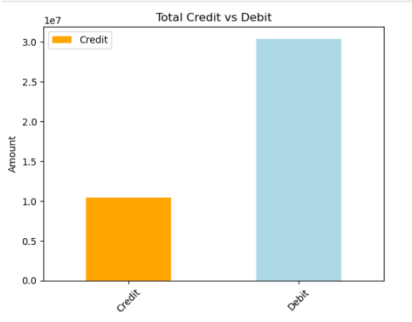
Insights:
- Debit transactions are higher than credit transactions.
- This indicates higher spending behavior among customers compared to incoming funds.

5.3 Account Balance Distribution
Analyzed the distribution of account balances across customers using a histogram.

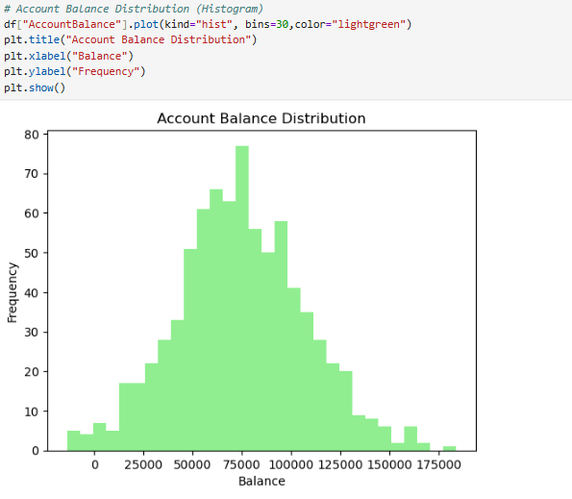

Insights:
- Most customers fall within a mid-range balance.
- A smaller number of customers have very high or very low balances, indicating variation in financial stability.

5.4 Monthly Transaction Trend
Analyzed transaction trends over time to identify patterns in customer activity.

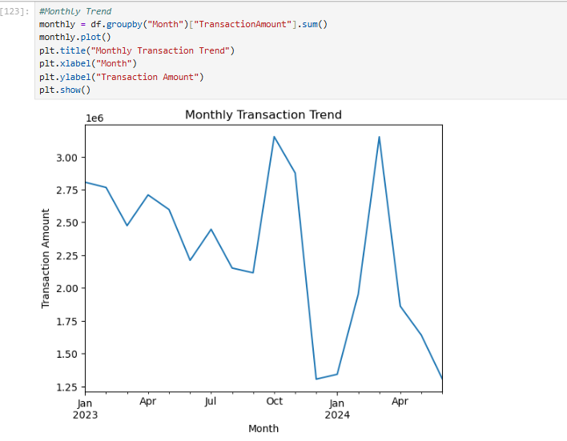
Insights:
- Transaction amounts fluctuate over time, showing changes in customer activity.
- Peaks in certain months indicate higher financial activity, while drops may indicate lower engagement.
Task 5 Summary-
Visualizations reveal key patterns in customer transaction behavior, including spending trends, balance distribution, and activity over time.
These insights help in understanding customer engagement and identifying potential financial risks.

Task 6: Hypothesis Testing
6.1 Grouping Customers (High vs Low Volume)
Customers were divided into High and Low transaction volume groups based on the number of transactions per account.
- High Volume: Accounts with transaction count above median
- Low Volume: Accounts with transaction count below median
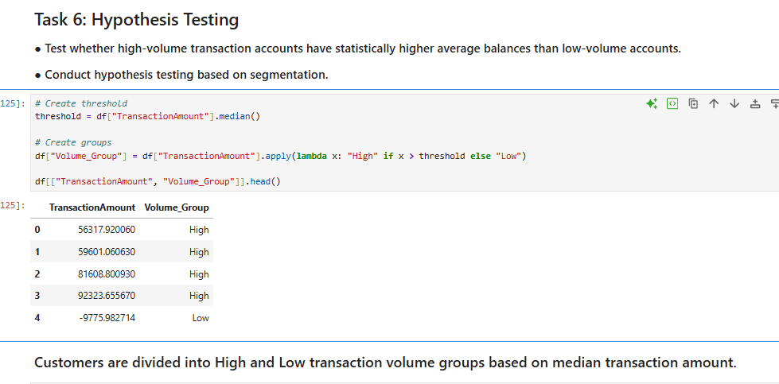
Insights:
Customers are segmented into two groups to compare their average account balances.

6.2 Balance Comparison
Compared account balances between high-volume and low-volume customers using a boxplot.

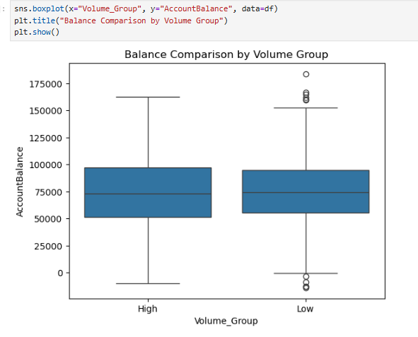
Insights:
- The distribution of balances appears similar for both groups.
- There is no clear visual difference in average balances between high and low transaction customers.

6.3 Hypothesis Testing (T-Test)
Performed an independent t-test to check whether there is a significant difference in average account balances between high and low transaction groups.
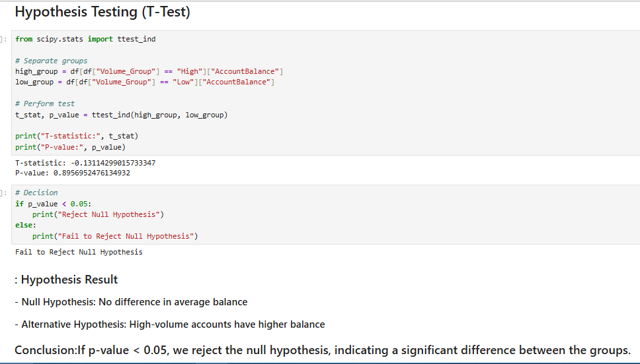
Hypothesis –
- Null Hypothesis (H₀): There is no significant difference in average account balance between the two groups.
- Alternative Hypothesis (H₁): High-volume transaction accounts have higher average balances.
Result -The p-value obtained is greater than 0.05, indicating that the result is not statistically significant.
Conclusion:
Fail to reject the null hypothesis.
This means there is no strong evidence to conclude that high-volume transaction accounts have higher average balances than low-volume accounts.
Task 6 Summary-
Hypothesis testing shows that transaction volume does not significantly impact account balance.
This suggests that customer spending frequency does not necessarily indicate higher financial strength.
Final Conclusion:
- This project analyzed customer financial behavior using transaction data to identify patterns in spending, activity, and financial risk.
- The analysis shows that customer activity varies, with some accounts highly active while others remain inactive, indicating differences in engagement.
- Debit transactions are higher in several periods, reflecting increased spending behavior among customers.
- Customer segmentation helped identify high-value customers as well as low-balance and inactive accounts that may pose financial risk.
- Hypothesis testing indicates no significant difference in average balances between high and low transaction volume groups.
Final Insights:
- Customers show varying levels of engagement, from highly active to completely inactive accounts.
- Debit transactions dominate in several cases, indicating higher spending behavior.
- Inactive accounts suggest potential customer churn and require attention.
- High net inflow customers contribute significantly to overall financial activity.
- Low or near-zero balance accounts indicate possible financial instability.
Final Recommendations:
- Monitor inactive accounts and implement strategies to improve customer engagement.
- Track high-risk accounts with irregular or large transactions for better risk management.
- Provide personalized services to high-value customers to retain them.
- Set alerts for unusual transaction patterns to reduce potential fraud risk.
- Encourage customers to maintain healthy account balances through awareness and financial planning.

THANK YOU!

Video Link - https://www.loom.com/share/de4c5380524841048294fa2a1604524f

